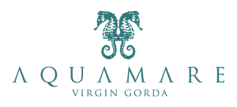

Villa Aquamare
Secret Retreats, Exclusive Celebrations

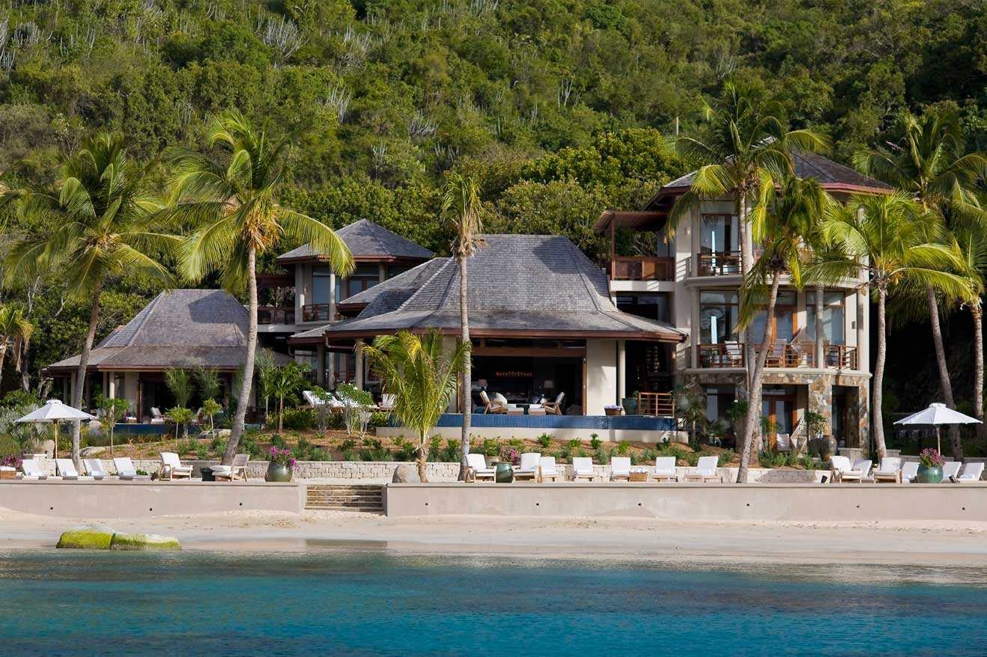

December 9, 2013. Virgin Gorda, British Virgin Islands – For Hollywood stars, big league politicians and top tier business executives, the secret getaway for major life celebrations is Villa Aquamare, one of the most exclusive enclaves in the world. Set on a sandy beach on Virgin Gorda, Villa Aquamare is a secluded luxury compound that’s larger than many Caribbean hotel properties, with three separate 8,000 square foot villas surrounded by gardens. Thanks to 15 suites, floor-to-ceiling windows overlooking the islets in the Drake Channel, a Beach Park and three infinity pools, Villa Aquamare combines the design and services of a five-star hotel with the exclusivity of a private villa stay.
Celebration Perfected at Villa Aquamare
Villa Aquamare is the ideal for Secret Retreats, Exclusive Celebrations, a unique setting for those monumental, life-changing celebrations, from intimate weddings to significant birthdays. It’s the Caribbean’s most coveted, private locale for extraordinary dusk-to-dawn parties. Villa Aquamare’s secluded waterfront Beach Park forms the backdrop for dramatic Caribbean sunsets – and sunrises. It’s that rare private place where a party, wild or subdued, won’t make it onto tomorrow’s celebrity gossip websites. That’s why everyone from Hollywood to Capitol Hill books Villa Aquamare for its discretion, five-star services and seclusion, a place where they can bring their tribe.
Dramatic Spaces Designed for Celebrations
Each one of Villa Aquamare’s three villas has five suites, three of them master suites, each one with a spacious ensuite marble bathroom equipped with a Jacuzzi tub and sensual alfresco rain showers. Villa Aquamare has dramatic open spaces for gathering and celebrating, as well as quiet nooks for guests to recharge. Each one of the villas has a living room with a 30 foot vaulted ceiling, a dining room, gourmet kitchen, multiple terraces and an infinity pool. Hi res images are available via Dropbox.
Villa Aquamare has both the expertise and a staff of experts to coordinate a celebratory gathering:
- On-site Villa Host
- Party Planners
- Wedding Coordinators, local as well as through The Wedding Library
- Staff of housekeepers, butlers, chefs

Secret Retreats, Exclusive Celebrations at Villa Aquamare
- 7 night takeover of Villa Aquamare’s three 8,000 square foot five-bedroom villas. Each villa features a spacious living room and dining room area, gourmet kitchen, multiple terraces, and a private infinity pool. Combined, the three villas can sleep a total of 30 guests.
- Meet & Greet at airport or Spanish Town Marina
- Land transfers to the Villa
- Use of the Beach Park, with kayaks and snorkeling equipment to explore the reef that lies just offshore
- Priced from $70, 500 for 7 nights, based on maximum occupancy of 30 guests. Taxes and service charges are extra
- Valid through April 30, 2014
- For reservations or more information, visit www.villaaquamare.com or call (787)-461-2638.

Villa Aquamare, set on the scenic Western coast of Virgin Gorda at Mahoe Bay along half a mile of pristine beach frontage, consists of three 8,000 square-foot private villas. Designed and constructed specifically as elite villa vacation homes, with multiple ensuite master bedrooms, spacious living areas and professional-grade kitchens, Aquamare is the new benchmark for luxury villa rentals on one of the B.V.I.'s quietest and most exclusive islands. For reservations or more information, visit www.villaaquamare.com or call (787) 461-2638
Facebook Villa Aquamare
Twitter Villa Aquamare

# # #
U.S. Media Contact:
ConranPR
Gayle Conran
212.447.1010
gconran@conranpr.com

